Our Mission and Values

Commsworld aim is to be Provider of choice for digital connectivity solutions specialising in exceptional delivery to clients across all sectors. We manage and control the largest privately funded Optical Core network in the UK with extensive on-net Metro reach.

We offer our clients a broad portfolio of Cloud, Security and Voice solutions delivering accessibility to client Applications and Data across the world. All supported by our strong in-house Service & Support capabilities, ISO accreditations and powerful accessible CRM portal.

Core Values

- Motivated and Skilled people, doing the best work of their lives
- Accountability, Integrity and Trust
- Innovation – Ahead of the Curve
- Placing clients at the heart of everything we do.

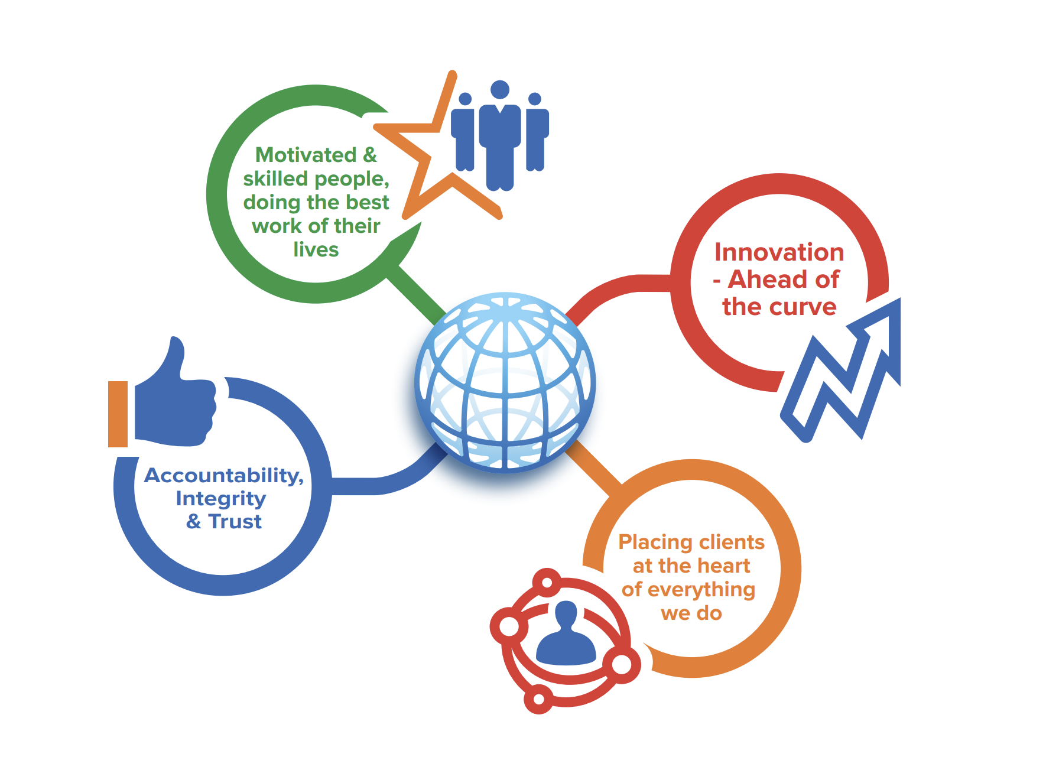

Commitments & Accreditations

Commsworld are a member of the Climate Hub and committed to halving our emissions by 2030 and being Net Zero by 2050. Commsworld activities are also integral to supporting our ISO14001 and Ecovadis accreditations (Sliver level).
Commsworld started assessing and developing a Carbon Reduction Plan at the end of 2022. This Plan is still being developed and with a baseline carbon footprint still to be established. This will be followed by establishing scoring values for Scopes 1, 2 and 3. Commsworld have engaged with two external Consultant organisations who are supporting us in the development of our Carbon Reduction Plan. This Plan will be finalised and published by the end of April 2023 and will align with Public Note 06/21 requirements.

Business ethics & Compliance framework

At the core of this framework is strong governance and a robust risk and compliance framework. This framework is supported by procedures and systems to ensure that we apply, at all times, high levels of personal and professional integrity. With the support of our risk and compliance function we have put in place the necessary policies and procedures, as well as ongoing training throughout our employees’ careers to ensure that the highest standards of compliance are embedded right across our operations.

We will not enter into, or maintain, relationships with individuals or organisations engaged in, or suspected of having engaged in, illegal activities which go against our code of ethics as a buisness.

New clients are accepted in accordance not only with applicable laws, but also in accordance with our risk policies.

People and culture
Fostering openness, sustainability, and respect are our key objectives. We value everyone and strive to work as one team. We invest in our people and their working environment by creating and maintaining a safe and healthy working environment and ensuring their ongoing professional and personal development.
We strive to create a workplace in which there is mutual trust and respect and where every person feels responsible for the performance and reputation of our buisness. We respect one another and each other’s individual rights and customs. We work towards achieving a diverse workforce, recruiting, employing and promoting people only on the basis of objective criteria and the qualifications and abilities needed for the job to be performed.
We continuously engage with our people at a local and at a group level to translate our core values into action. We do this through communications and engagement, information and consultation, so as to assist them in realising their full potential.
We promote integrity and professionalism throughout our business and pride ourselves in leading by example - which we do by setting the right tone right from the top of our organisation.

Corporate Social Responsibility
We encourage our people to give something back to their local communities, whether it is time, effort or a financial contribution. Our key focus areas are the community as well as education and the environment. It’s important that we play our part to build a better world for current and future generations. Our support is delivered through initiatives that:
- Support local communities and those in need.
- Support local initiatives for the development and education of young people in the areas we live and work.
- Support our environment and reduce our carbon footprint.
- Partnering with Charities who make an impact in the communities we support.

